**Installing Python**

1. Anaconda 4.2.0, Python 3.5 version

installation: https://www.continuum.io/downloads

2. ibPy

installation: pip install IbPy2

3. configparser

installation: pip install configparser

**Running the updater**

1. Install all requirements listed in Requirements.txt file.
2. Open your TWS
3. In TWS/Settings/API/Settings modify settings as shown in the screenshot below

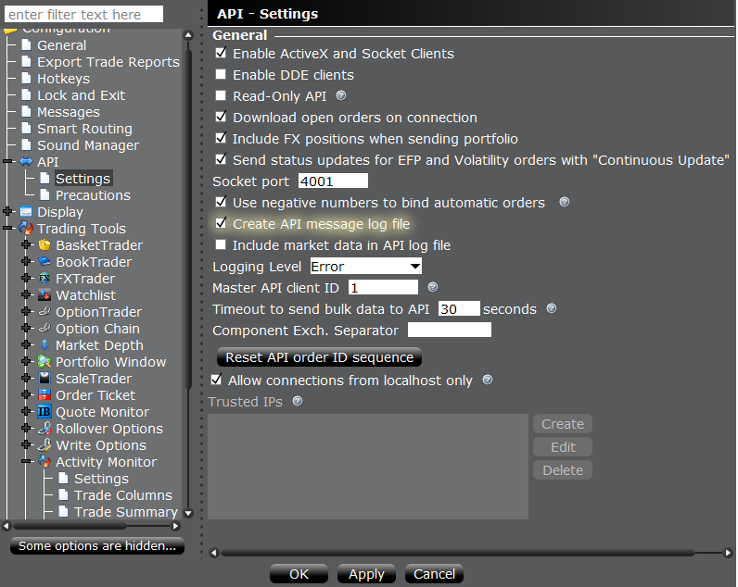

1. In TWS\Settings\API\Precautions apply the following settings

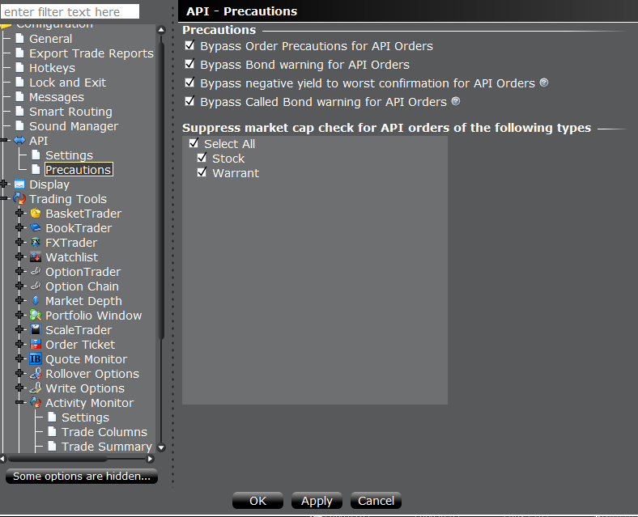

1. Open the Config.ini file and set parameters

**Section = [QueryParams]**

* host - ‘localhost’ if the updater is running from the same machine as TWS or IB Gateway
* port - should be the same port as seen in TWS ( the screenshot in point 2)
* client_id - any positive integer.
* is_use_gateway - this parameter tells the updater which platform is used to connect to IB.

False = TWS,

True = IB Gateway.

* req_interval_secs - interval size in seconds for requesting data from IB. Should be a positive float
* ib_field_list – possible fields are provided in IB_account_data.txt file. Should be provided in the form of the python list.

**Section = [PostParams]**

* server_name_list – corresponding names of ib_field_list in the database
* h – ‘q5jnqwvq2k7z4jhrj55vezy2fxp9gfyjt6aa’, should be a string
* url – ‘http://my.lefcapital.com/1/ibapi.cfm’, should be a string
* restricted_accounts – Accounts that should not be updated

1. Place the Config.ini file in the same directory as AccountUpdater.py (or provide the alternative path in AccountUpdater.py)
2. Run AccountUpdater.py